NSW state election: ALP cries foul in tracking down ex-museum boss
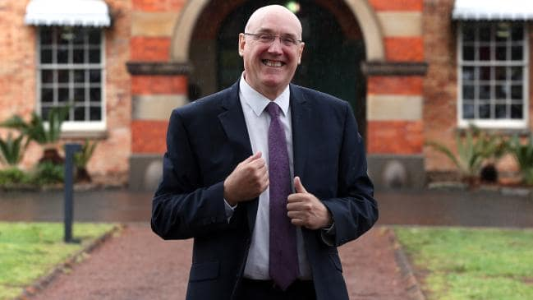Western Sydney University vice-chancellor Barney Glover. Professor Glover is also chairman of the Museum of Applied Arts and Sciences trust, which oversees Sydney’s Powerhouse Museum. Picture: Jane Dempster/The Australian
- EXCLUSIVE

ANDREW CLENNELL
NSW POLITICAL EDITOR
@aclennell

- 12:00AM MARCH 13, 2019
- 2 COMMENTS
Labor’s arts spokesman Walt Secord has made a complaint alleging contempt of parliament by the government after a committee examining a proposal to move the Powerhouse Museum was not provided with contact details for the museum’s former boss, Dolla Merrillees.
The committee was seeking to question Ms Merrillees over the cash-strapped museum staging a lavish $388,000 party that made a loss of $215,210.
Mr Secord has now discovered that Ms Merrillees, who left the museum mid-last year, was contactable and was working at the Western Sydney University for vice-chancellor Barney Glover, who is chair of the Powerhouse.
The inquiry was set up to investigate the Berejiklian government’s proposal to move the museum to Parramatta at a cost of up to $1 billion.
In a letter to the committee yesterday, Mr Secord said its secretariat had asked Create NSW to locate Ms Merrillees, who resigned in July 2018 from her position after the infamous fashion fundraising gala ball.
But both Create NSW and MAAS said they did not know her whereabouts and thus she would not be able to provide evidence to the parliamentary committee.
“However, it has been brought to the opposition’s attention by whistleblowers within Western Sydney University that she has been working there for a period,” Mr Secord said.
“It is inconceivable that Create NSW nor MAAS would have been unaware of Ms Merrillees’s whereabouts as Barney Glover is both president of the board of trustees and vice-chancellor and president of Western Sydney University.”
Mr Secord said when parliament resumed there was a clear case for a referral to the privileges committee “as Create NSW and/or MAAS staff knowingly thwarted and obstructed a formal request’’ from the inquiry.
A letter from Create NSW’s Alex O’Mara to the committee yesterday stated it had consulted the museum and “the department is … not able to assist with contact details for Ms Merrillees”.
Professor Glover said yesterday the issue was “nothing to do with me”. “I have never had a request or an inquiry from the museum or Create NSW to provide any details of any person in relation to the parliamentary inquiry.”
Create NSW said it had acted with “complete integrity and in accordace with all requests from all parliamentary inquiries’’.

