16 February, 2018
Sydney Morning Herald
Linda Morris

Former premier Mike Baird, Mirvac officials to be called to give evidence in Powerhouse inquiry
A parliamentary committee scrutinising the NSW Government's decision to relocate the Powerhouse Museum to Parramatta at a potential cost to taxpayers of up to $1.5 billion has given the former NSW premier Mike Baird an ultimatum: either appear before it or be forced.
Mr Baird is one of three prominent business leaders who has been given 24 hours to reconsider his refusal to front the Upper House inquiry - or be summonsed to do so.

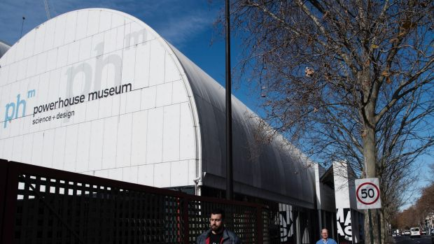
A parliamentary committee is scrutinising the decision to relocate the Powerhouse Museum to Parramatta. Photo: Louise Kennerley

Mr Baird's former chief of staff, Bay Warburton, who joined Mirvac as the head of Stakeholder Relations last August, is also believed to be among those summoned to give evidence as soon as next month.
The move suggests the committee, chaired by Shooters, Fishers and Farmers MLC Robert Borsak, may be pursuing information around any commercial plans for the existing Ultimo site or the museum's proposed riverside home in Parramatta.

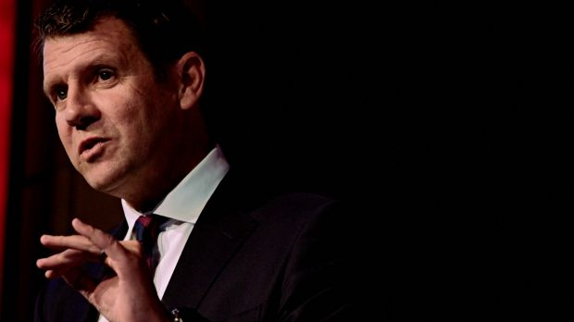
It was former premier Baird who announced the plan to create an arts and cultural precinct in Western Sydney. Photo: Ben Clement
A majority of the seven-member committee voted Thursday to assert its authority over witnesses which had declined invitations to give evidence. The committee concedes, however, it cannot force Mr Baird's successor, Gladys Berejiklian, to appear before it.

It was former premier Baird who in 2015 announced the plan to the Powerhouse Museum to create an arts and cultural precinct in Western Sydney.
An interim report by the inquiry was scathing of the government's pre-emptive decision to move the museum from Ultimo in Sydney's CBD before preparation of a fully-costed business plan. It found the relocation could cost up to $1.5 billion and that much of this cost would be "wasted in the expensive project of moving and re-purposing the existing collection".

The shift had the potential to destroy a cultural icon and amounted to an "act of vandalism by this government", the report said.
Investment in a migration museum and a dedicated centre for Aboriginal art and culture was recommended for the Parramatta precinct with savings to be spent on regional and rural museums and galleries.

"From the very start of this inquiry the Government has obfuscated and [refused] to release details of the business case for relocating the Powerhouse Museum from Ultimo to Parramatta," Mr Borsak said. "Nobody has provided a straight answer on why this decision was made before the Government knew how much it would cost, how they could move the Powerhouse Museum or whether the plan is even value for money. The public has a right to know the reason for such secrecy."

The Powerhouse business case, belatedly commissioned last year, is understood to be complete and is expected to be presented to NSW Cabinet within days.
The committee has also sought advice from the Clerk of the Parliaments to access Cabinet documents which have been withheld from public scrutiny.
Subpoenas were last invoked by the committee in the parliamentary inquiry into the police bugging scandals involving the former NSW police deputy Nick Kaldas and his one-time rival Catherine Burn.

http://www.smh.com.au/nsw/former-premier-mike-baird-mirvac-officials-to-be-called-to-give-evidence-in-powerhouse-inquiry-20180214-h0w3r2.html

